**There are four colorings that you SHALL use to specify the use of GenAI on your reports:**

|  |  |
| --- | --- |
| **The text was generated by GenAI and you are using it without any change. If you are using it without any change, the highlight color used should be yellow.** | **Yellow** |
| **This part of the text was generated by GenAI but you changed it. If you are using a GenAI text that was changed, the highlight color to be used should be purple.** | **Purple** |
| **This part of the text was generated by you, but you gave it to GenAI to improve the language (e.g. to make it more formal). In this case the highlight to be used should be grey.** | **Grey** |
| **This part of the text was directly written by the team members but the idea about this text was proposed by the GenAI. As team you took the idea of GenAI and formed your own sentences. In this case the highlight to be used should be turquoise.** | **Turquoise.** |

# First Level Title

This text was written by us without the use of any GenAI tool. Therefore as it is written by us, we are not going to highlight it. This text was generate by GenAI and we are using it without any change. If you are using it without any change, the highlight color used should be yellow.[1]

This part of the text was generated by GenAI but we changed it. If you are using a GenAI text that was changed, the highlight color to be used should be purple.[2]

This part of the text was generated by us, but we gave it to GenAI to improve the language (e.g. to make it more formal). In this case the highlight to be used should be grey. [3]

This part of the text was directly written by the team members but the idea about this text was proposed by the GenAI. As team you took the idea of GenAI and formed your own sentences. In this case the highlight to be used should be turquoise.[4]

The GenAI use should be denoted as a footnote next to each use. In the footnote three important information needs to be provided: a) the GenAI tool used, b) the prompt used, and c) the rationale and how you integrated it [1] [2].

# First Level Title

This text was written by us without the use of any GenAI tool. Therefore as it is written by us, we are not going to highlight it. This text was generate by GenAI and we are using it without any change. If you are using it without any change, the highlight color used should be yellow.[5]

This part of the text was generated by GenAI but we changed it. If you are using a GenAI text that was changed, the highlight color to be used should be purple.[6]

This part of the text was generated by us, but we gave it to GenAI to improve the language (e.g. to make it more formal). In this case the highlight to be used should be grey. [7]

The GenAI use should be denoted as a footnote next to each use. In the footnote three important information needs to be provided: a) the GenAI tool used, b) the prompt used, and c) the rationale and how you integrated it [1] [2].

# First Level Title

This text was written by us without the use of any GenAI tool. Therefore as it is written by us, we are not going to highlight it. This text was generate by GenAI and we are using it without any change. If you are using it without any change, the highlight color used should be yellow.[8]

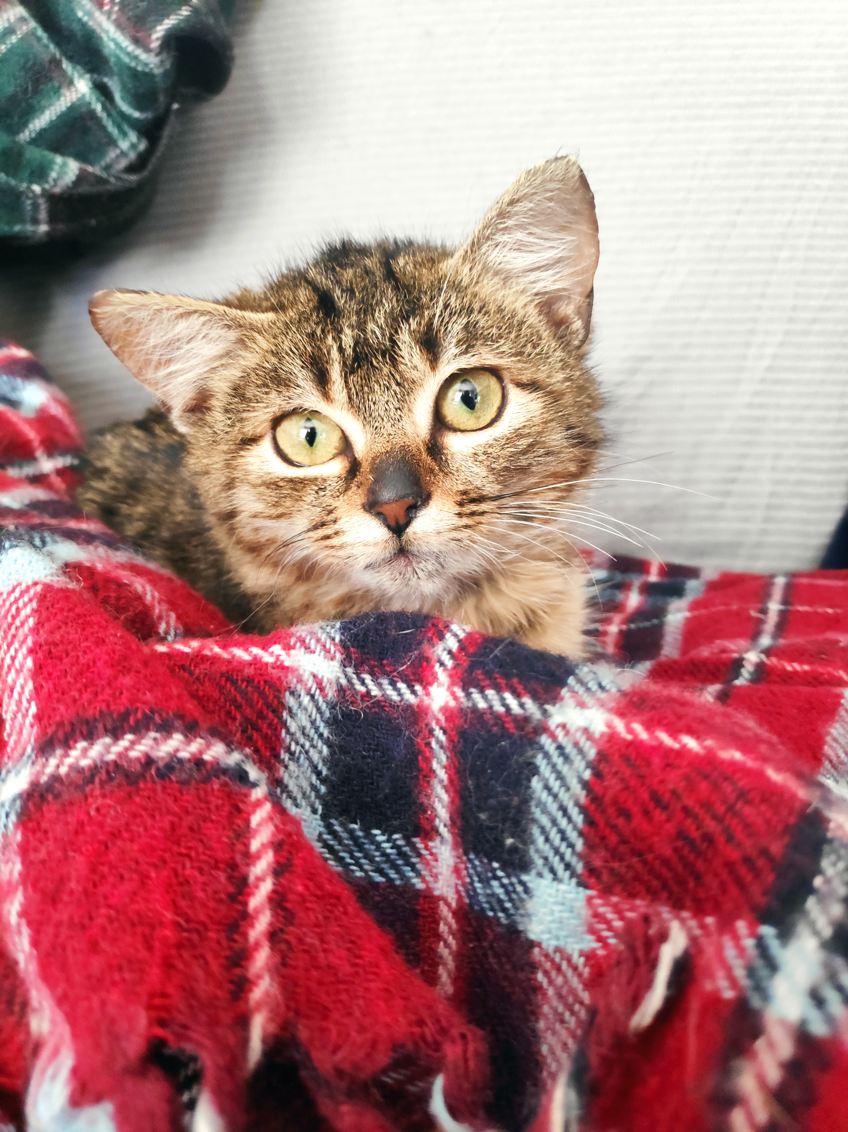

Figure Figure captions need to be below the figure, and you may generate your figures with the use of GenAI tools [9].

This part of the text was directly written by the team members but the idea about this text was proposed by the GenAI. As team you took the idea of GenAI and formed your own sentences. In this case the highlight to be used should be turquoise.[10]

Table Table captions need to be on top of the table

|  |  |  |  |  |
| --- | --- | --- | --- | --- |
| **aaa** | **bbb** | **ccc** | **ddd** | **eee** |
|  |  |  |  |  |
|  |  |  |  |  |
|  |  |  |  |  |
|  |  |  |  |  |
|  |  |  |  |  |
|  |  |  |  |  |

# First Level Title

This text was written by us without the use of any GenAI tool. Therefore as it is written by us, we are not going to highlight it. This text was generate by GenAI and we are using it without any change. If you are using it without any change, the highlight color used should be yellow.[11]

This part of the text was generated by GenAI but we changed it. If you are using a GenAI text that was changed, the highlight color to be used should be purple.[12]

This part of the text was generated by us, but we gave it to GenAI to improve the language (e.g. to make it more formal). In this case the highlight to be used should be grey. [13]

The GenAI use should be denoted as a footnote next to each use. In the footnote three important information needs to be provided: a) the GenAI tool used, b) the prompt used, and c) the rationale and how you integrated it [1] [2].

This part of the text was directly written by the team members but the idea about this text was proposed by the GenAI. As team you took the idea of GenAI and formed your own sentences. In this case the highlight to be used should be turquoise.[14]

1. GenAI tool: ChatGPT 3.5

   Prompt: “When you stop to look, you can always see me. But if you try to touch me, you can never feel me. Although you walk towards me, I remain the same distance from you. What am I?”

   Rationale: To find an answer.
2. GenAI tool: BERT

   Prompt: “I cannot talk, but I always reply when spoken to. What am I?”

   Rationale: To enhance our answer.
3. GenAI tool: OPT

   Prompt: “What is always in front of you, but can’t be seen?”

   Rationale: To improve and make more formal the text of our answers.
4. GenAI tool ChatGPT 3.5

   Prompt: “give me an idea for a requirement”
5. GenAI tool: ChatGPT 3.5

   Prompt: “When you stop to look, you can always see me. But if you try to touch me, you can never feel me. Although you walk towards me, I remain the same distance from you. What am I?”

   Rationale: To find an answer.
6. GenAI tool: BERT

   Prompt: “I cannot talk, but I always reply when spoken to. What am I?”

   Rationale: To enhance our answer.
7. GenAI tool: OPT

   Prompt: “What is always in front of you, but can’t be seen?”

   Rationale: To improve and make more formal the text of our answers.
8. GenAI tool: ChatGPT 3.5

   Prompt: “When you stop to look, you can always see me. But if you try to touch me, you can never feel me. Although you walk towards me, I remain the same distance from you. What am I?”

   Rationale: To find an answer.
9. GenAI tool: DALL-E

   Prompt: “Give me the world’s most beautiful cat”
10. GenAI tool ChatGPT 3.5

    Prompt: “give me an idea for a requirement”
11. GenAI tool: ChatGPT 3.5

    Prompt: “When you stop to look, you can always see me. But if you try to touch me, you can never feel me. Although you walk towards me, I remain the same distance from you. What am I?”

    Rationale: To find an answer.
12. GenAI tool: BERT

    Prompt: “I cannot talk, but I always reply when spoken to. What am I?”

    Rationale: To enhance our answer.
13. GenAI tool: OPT

    Prompt: “What is always in front of you, but can’t be seen?”

    Rationale: To improve and make more formal the text of our answers.
14. GenAI tool ChatGPT 3.5

    Prompt: “give me an idea for a requirement”